Phase 2: Discover
  - Presentation Guidelines
- 15 Minutes for the presentation
- 3-5 Mins for Q&A

Introduction Slides (1-2 minutes)

Title Slide
Must contain:
- “DAEN 460 - Capstone”
- Sponsor company name
- “Phase 2”
- A Texas A&M logo
- Team number
- Project Title

Team Introduction Slide 1
- Picture, name, and fun fact answer of each group member
  - Phase 2 Fun Fact: Who would you like to share a meal with and where?
    - Person can be dead or alive, language barrier doesn't exist
    - Example: "I'd grab greasy fries with Sherlock Holmes beneath London skies, Swapping sharp little clues between ketchup and pies."

Team Introduction Slide 2
- Picture and name of project sponsor
  - You can use the sponsor’s logo instead of a headshot/photo if there’s not an openly accessible picture of them online
  - Picture and name of faculty advisor
  - Mention names/titles, but introductions not needed again

Team Introduction Slide 2
- Problem statement slides from presentation 1 (as revised!)

Body Slides

As-Is CONOPS (3-5 mins)
- Each team will create a model (or set of models) to capture the current state of their target system (or system of systems).
  - “As-Is”: Current
  - “CONOPS”: Concept of Operations
1. Purpose and Scope
      - Define the mission of the data engineering capability.
      - Identify business domains, stakeholders, and decision contexts supported.
      - Clarify boundaries (analytical, operational, streaming, ML enablement, etc.).
2. Operational Context
      - Current state architecture (sources, platforms, consumers).
      - Regulatory, security, and governance constraints.
      - Data scale characteristics (volume, velocity, variety).
      - Organizational model (centralized, federated, data mesh, hybrid).
3. Stakeholders and Roles
      - Data producers (application teams, external vendors).
      - Data engineering team (platform, pipelines, reliability).
      - Data consumers (BI, data science, ML, operations).
      - Governance and compliance stakeholders.
      - Executive sponsors.
4. High-Level Operating Model
      - Ingestion patterns (batch, streaming, CDC, APIs).
      - Transformation layers (raw → curated → semantic).
      - Storage paradigms (lake, warehouse, lakehouse).
      - Data access patterns (SQL, APIs, feature stores).
      - Observability and reliability model (SLAs, SLOs, error budgets).
5. Data Lifecycle
      - Source onboarding.
      - Validation and quality enforcement.
      - Lineage tracking and metadata capture.
      - Retention and archival.
      - Decommissioning and schema evolution.
6. Governance and Controls
      - Data classification and access control.
      - Privacy and regulatory compliance.
      - Master/reference data management.
      - Auditability and traceability.
7. Technology and Tooling
      - Orchestration framework.
      - Storage and compute infrastructure.
      - CI/CD and infrastructure-as-code.
      - Monitoring and alerting stack.
8. Operational Scenarios
      - New data product onboarding.
      - Schema change handling.
      - Pipeline failure and recovery.
      - Incident response workflow.
      - Scaling for demand spikes.
9. Metrics and Success Criteria
      - Pipeline reliability (uptime, latency).
      - Data quality KPIs.
      - Time-to-onboard new sources.
      - Cost efficiency per workload.
      - Consumer satisfaction/adoption.
10. Risks and Assumptions
      - Upstream instability.
      - Talent constraints.
      - Platform lock-in.
      - Evolving regulatory landscape.
      - Growth projections.
11. Future State Vision
      - Self-service enablement maturity.
      - Automation depth (data contracts, testing).
      - Platform standardization.
      - Integration with ML and real-time decision systems.
- This early in the project, it may be difficult to create a model that holistically captures your As-Is Concept of Operations. This is particularly applicable to projects requiring a site visit.
  - HOWEVER, the fact that you are still planning a site visit (or a meeting with personnel who have technical knowledge of the system-of-interest) is no reason to hold off on modeling your system.
- Create a model or set of models that capture the activity/process/information flow(s) pertinent to the challenge presented by your sponsor.
- You must document & present the PVC for each model you create
  - Purpose: Why was the model created?
  - Viewpoint: From what point of view does the model give insight into the modeled system’s workings?
    - Process engineer (backend), customer (frontend), manager, trainee, etc.
  - Context: Provide a concise list of information that builds up context for understanding the modeled system
  - The PVC doesn’t need to be fancy, think of how you’d explain the model in conversation and let that drive your PVC definitions
- Important Suggestions: When presenting models, you want to make it as easy as possible for the audience to understand what they’re looking at. Do not assume you’re interacting with another engineer.
  - Use the whole slide if the picture is highly detailed
  - Present only chunks at a time if a view of the whole model is difficult to follow (the morph tool in PPT animations and selectively revealing regions with animated shapes are great for “chunking” the presentation of your model)
  - Use annotations: box important areas, use circles and arrows, command the attention of the audience as you guide them through your model
  - Model slides should NOT be wordy!
Remember Jose and JP wise words, “you are the presentation.”
- Pro tip: Explore as many avenues as possible! Use the bulk of your team’s contributions to approach the As-Is model rather than focus all your efforts on a single model (or, even worse, assign a single person to creating the As-Is CONOPS).
  - Don’t ever throw away any work/progress, you never know when it may become relevant or helpful down the line. Keep things well documented and as always, throw stuff that may be helpful in the appendix of your Phase 2 slide deck.
- See the Phase 2 module for additional materials/examples.

System Requirements Definition (3-4 minutes)
- Now that you understand your As-Is system, it is time to write a set of requirements specifying how your system will act in the desired future-state
- With clear customer needs statements, your team can shift gears to writing system requirements. Below is the link to a video that very clearly explains system requirements (it’s the 4th video in a series about systems engineering, watching the first three is also highly encouraged): An Introduction to Requirements | Systems Engineering, Part 4 https://youtu.be/Iblo2Il-pOA?si=GtSwMNo6oG5i5jPw
- Here are the key points you should keep in mind when writing requirements as a team
  - What is a requirement?
    - “Requirements record and describe what needs to be designed and they provide how project success will be determined”.
  - How do you write a requirement?
    - “A requirement must be clear, concise, and unambiguous”.
    - Requirements are written as: “The system shall…”
    - Each requirement should be “atomic”, meaning it should only contain one idea. For example:
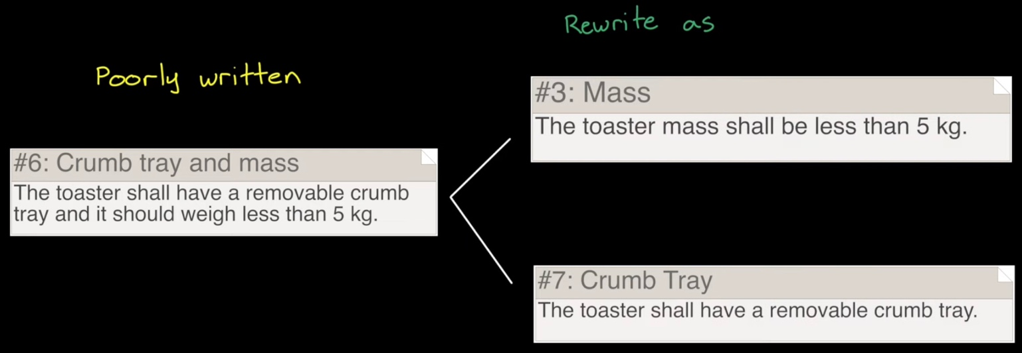
- What if my system needs a complex set of requirements?
  - If the scope of your problem entails more than a few requirements per customer need, it is beneficial to develop a requirements hierarchy.
  - Not all projects will require this level of depth for requirements.
  - A well-written requirement is verifiable.
    - Avoid words like “minimize” or “maximize” or “user-friendly”
    - Ultimately, requirements are met, or they are unmet. Make it easy for your team to “check the box” down the line.
  - Requirements DON’T specify implementation.
    - Requirements describe WHAT will be done.
    - Requirements don’t describe HOW it should be done.
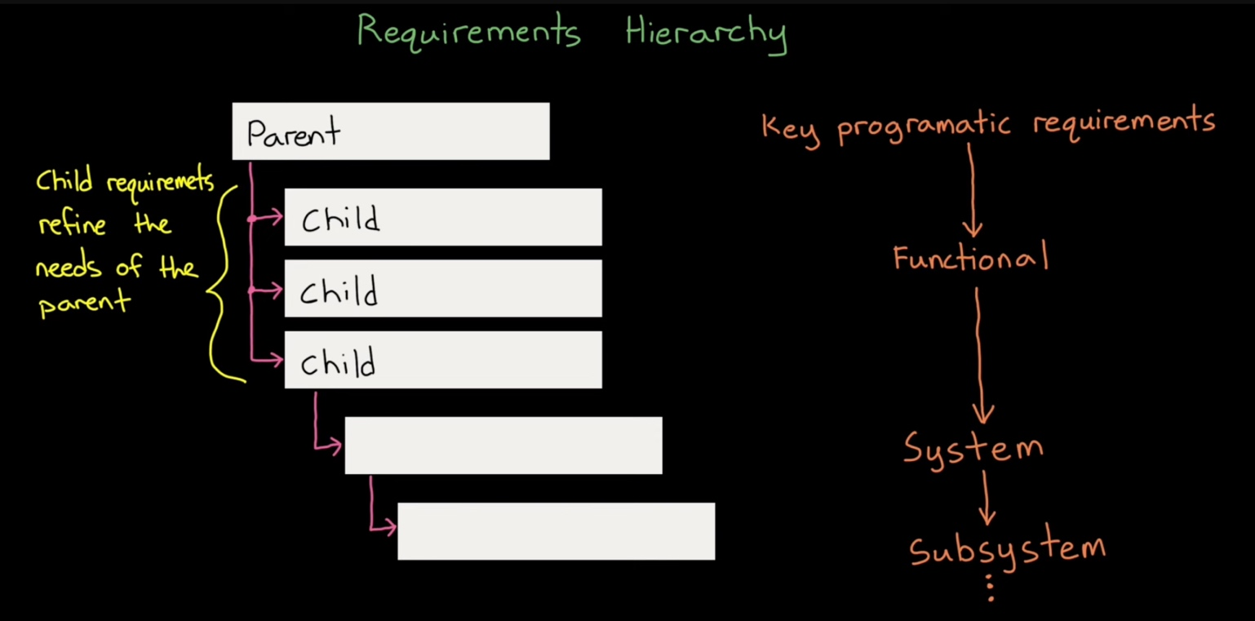
- NOTE: If you are working on a research project or your project feels “abstract” or qualitative in the sense that you are not designing a system that will be tangibly implemented, that’s OK!
  - The Needs Requirements Engineering Actions Technical Objectives approach is viable regardless of the nature of your project. This framework serves to set boundaries for your problem solving effort.
- Engineering Constraints and Standards: If your designed system aims to adhere to specific constraints/standards, it is beneficial to write them in as requirements

Engineering Actions (3-4 minutes)
- With Customer Needs and System Requirements established, you can move on to developing Engineering Actions.
- Engineering actions are the specific actionable tasks by which system requirements are realized, fulfilling your technical objectives.
- Engineering actions transform the As-Is into the To-Be.
- Keep the means of implementing the action general, the purpose of an Engineering Action is to specify HOW its corresponding System Requirement will be achieved without binding you to a specific solution.
  - Example
    - Bad EA: "Create a Simio model and analyze arrivals at department X"
    - Good Set of EAs:
      - “Create a simulation model of department X”
      - “Analyze daily arrival trends of department X”
      - “Gather 1 shift of data targeting top three factors from daily arrival analysis of department X”
  - With your engineering actions developed, don’t hesitate to begin executing them! Our phase approach merely serves to guide the development of your project framework.
    - Stay flexible and open to iteration, ensuring actions align with evolving system requirements and technical objectives.
    - Thoroughly document each engineering action to maintain traceability and simplify the validation process.
    - Effective execution of engineering actions is crucial for transforming the system from the As-Is to the To-Be state.

Conclusion (2-3 minutes)

Traceability Matrix
- With Customer Needs, System Requirements, Engineering Actions, and Technical Objectives defined, place all four into a traceability matrix to show the interrelationships of your project drivers and efforts.
- You must serialize your Customer Needs, System Requirements, and Engineering
  - Actions
    - N1, N2, N3…
    - R1, R2, R3…
    - EA1, EA2, EA3…
    - TO1, TO2, TO3…
  - N’s, R’s, EA’s, and TO’s DON’T necessarily map 1-1. What this means is that it’s very unlikely that Need 1 has 1 requirement that will be fulfilled by 1 engineering action.
  - Each Customer Need may lead to one or many system requirements. Each system requirement may lead to one or many Engineering Actions that contribute to the fulfillment of one or many technical objectives.
    - This is why it’s important to keep strict serialization and mapping!
  - Teams have the liberty to choose how to go through with traceability. Excel tables are the standard and simplest way to do it, but there are other options
  - The relationship between customer needs, system requirements, engineering actions, and technical objectives is a hierarchical flow where customer needs define the system requirements, which guide the engineering actions necessary to achieve the technical objectives that fulfill the desired outcomes of the project.

Project Plan
- Show your project plan Gantt chart.
  - Start with overall view of project
  - Zoom in to current phase and indicate completed tasks/milestones

The Appendix
- Include Supporting Artifacts
  - Add tables, lists, figures, or other supporting materials in an Appendix to help answer questions during the Q&A.
- Organize Your Appendix
  - Ensure your Appendix includes a directory or table of contents at the beginning, with clear headers indicating the content of each section.
- Facilitate Accurate Grading
  - A well-organized Appendix helps our team accurately assess the technical aspects of your team’s progress.
    - We only see what you include in your slide deck!
- We can’t grade what we don’t see
  - Make sure your team includes the progress you’ve made in the phase. If you don’t include it, we don’t know it exists and can’t give you credit for it.

